

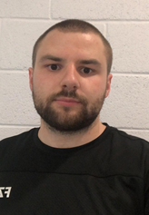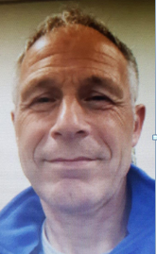
Ray Phipkin Chris Hall Ian Bosworth
LSBA Chairperson PC Chairperson LBA Chairperson
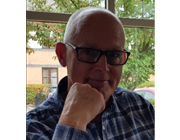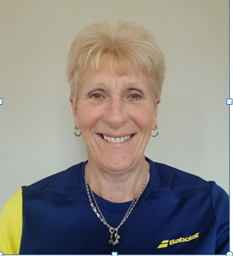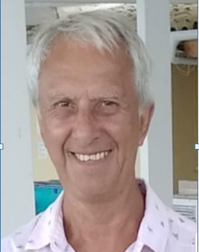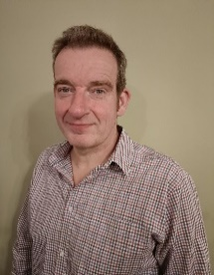
Dave Armstrong Carole Spencer Dave Watts Greg Howes Azrul Hilmi David Lunn
LSBA President LSBA Secretary Tournament City Development LSBA Fixtures LSBA Treasurer & Tournament Organiser & Officer / Schools Secretary Welfare Officer
Secretary LSBA Team Coach Coach
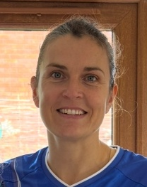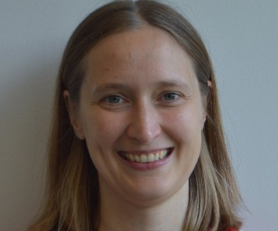
Chris Hall Anna Edwards Emma Ault Dalu Zhang Neil Southerd Beth Spencer Annette Kendrick Michelle Tung
Junior County U19 County U17 A Team U17 B Team U15 A Team U15 B Team U13 A Team U13 B Team
Captain / U18 Team Manager County Manager County Manager County Manager County Manager County Manager County Manager
ICT Team manager


Leicestershire Performance Centre

Chris Hall
PC Chairperson

Beth Spencer David Lunn Carole Spencer
PC Liaison Officer PC Welfare Officer Junior Clubs / Schools
Coordinator

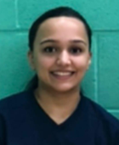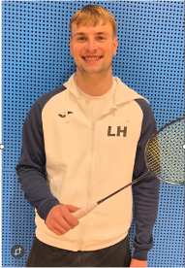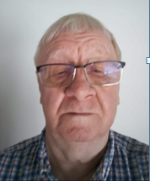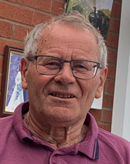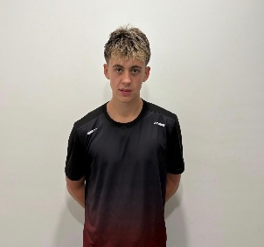
Chris Hall Jonty Russ Sarita Patel Luke Hoult Harry Clare Terry Talbot Graham Forryan Rowan Clark
PC Coach Head of Gold /Silver PC Coach PC Coach PC Coach PC Coach PC Coach PC Coach
Programme & PC Coach

